Lab 7
Name:Tran Quang Huy
Studentid: 106212636
7.1.1
The value displayed is 0x00000101, because 101 is interpreted as decimal and displayed in hexadecimal.
7.1.2
The value displayed is 0x0000101, because 0x101 is hexadecimal.
7.1.3
The value displayed is 00000005 because 0b101 is binary and equals decimal 5
7.1.4
No. The headers stay in hexadecimal because they represent memory addresses and should remain consistent.
7.2.1
The column header offsets increase in multiples of 0x4 because each memory word in the ARMLite simulator is 32 bits, which equals 4 bytes.
Since each memory address refers to 1 byte, the next memory word must start 4 bytes later in memory. Therefore, the addresses increase by 0x4 each time (for example: 0x0, 0x4, 0x8, 0xC, etc.).
This is why the column offsets go up in multiples of 0x4, as each step moves to the next 32-bit memory word.
7.3.1
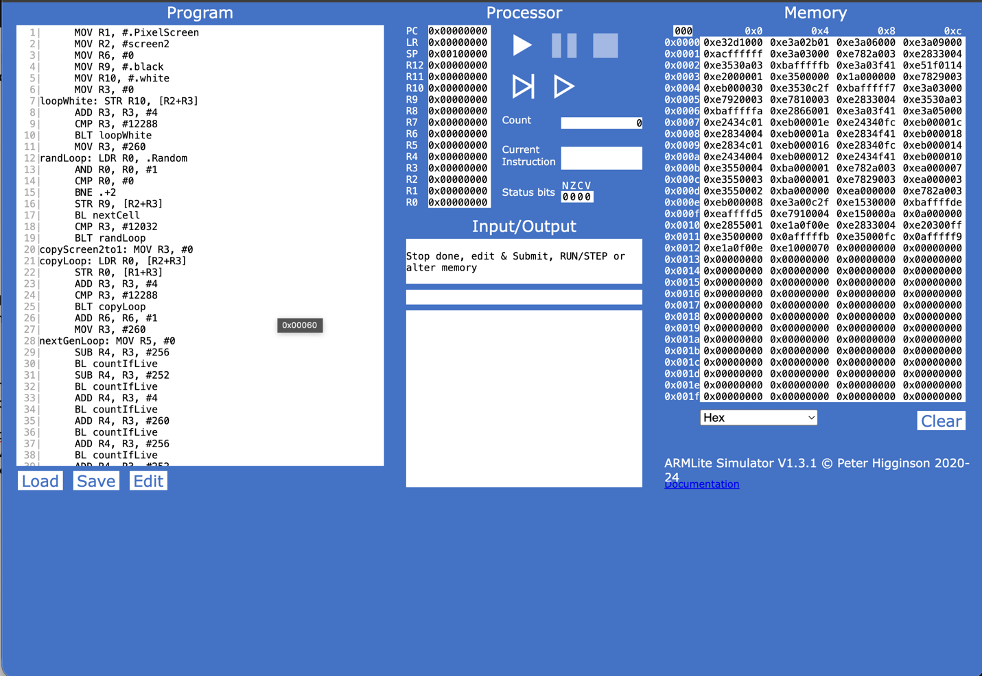
7.3.2
When I clicked submit, the assembler translated the assembly code into machine code and loaded it into memory. That’s why the memory window now shows a lot of values in the first rows.
Because ARMLite uses a Von Neumann architecture, both the program instructions and data are stored in the same memory, so the instructions from the program are stored there as machine code for the CPU to run.
7.3.3
The 5-digit hexadecimal value shown in the tooltip represents the memory address of that instruction.
Each instruction in the program is stored in a specific location in memory, and the address indicates where that instruction is located so the CPU can fetch and execute it.
After editing the code
Blank lines:
The blank lines disappear after submitting because the assembler ignores them. They don’t affect the program.
Additional spaces:
Nothing changes. The assembler ignores extra spaces as long as the instruction format is still correct.
Comments:
The comments are ignored by the assembler. They are only there to help people understand the code, so they are not turned into machine instructions.
Line numbers:
The line numbers may change after submitting because ARMLite generates them automatically to show the position of instructions.
Total number of instructions stored in memory:
The number of instructions stays the same. This is because blank lines, extra spaces, and comments are not actual instructions, so they are not stored in memory.
7.4.1
The orange highlighting shows the current instruction that the CPU is executing.
In the Program window it highlights the line of code being executed, and in the Memory window it shows the memory location of that instruction.
7.4.2
When clicking the red button, the program executes one instruction at a time. This is called single stepping, which lets us see exactly how the program runs step by step. It is useful for debugging because we can observe how registers or memory change after each instruction.
7.4.3
The processor pauses just before executing the line with the breakpoint. This allows us to check the state of the program before that instruction runs.
7.5.1
Before executing the instruction ADD R1, R0, #8, I think the CPU will take the value stored in R0 and add 8 to it, then store the result in R1.
At this point, R0 already contains the value 1 from the previous instruction MOV R0, #1.
So, the calculation should be:
1 + 8 = 9
I expect that after the execution the result will be:
R0 to still contain 0x00000001
R1 to contain 0x00000009 since that is the result of the addition.
7.5.2
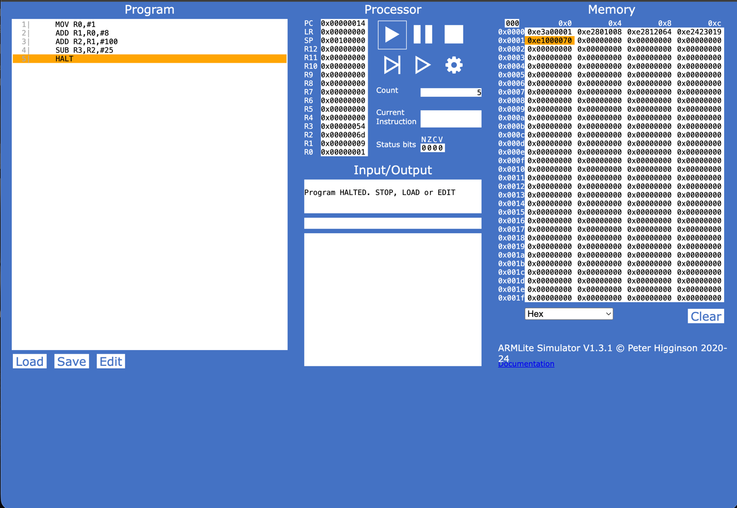
7.5.3
My calculation: 300-21+5+18-64+92 = 294
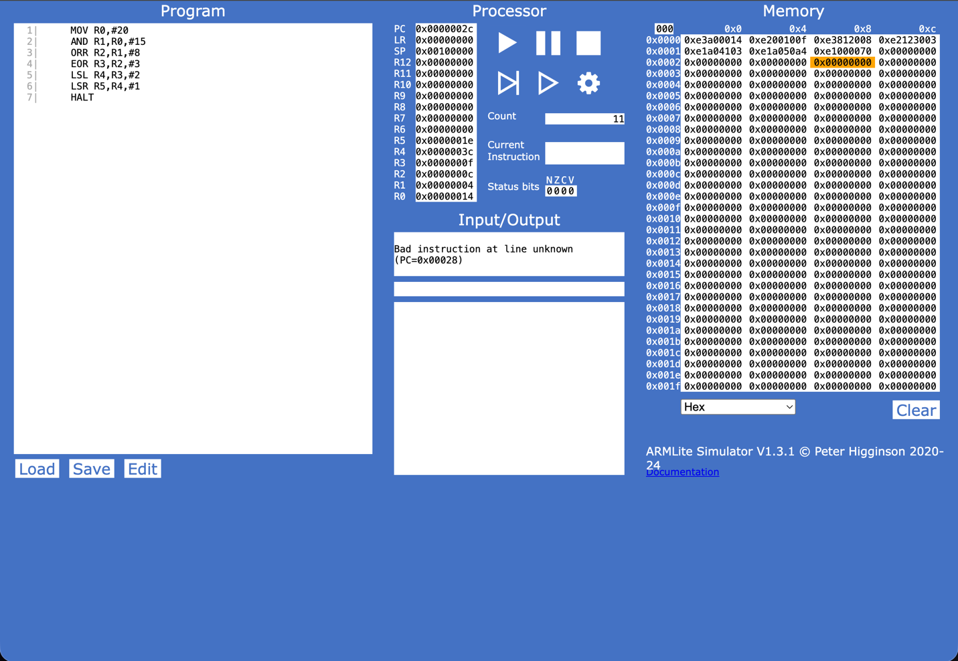
7.5.4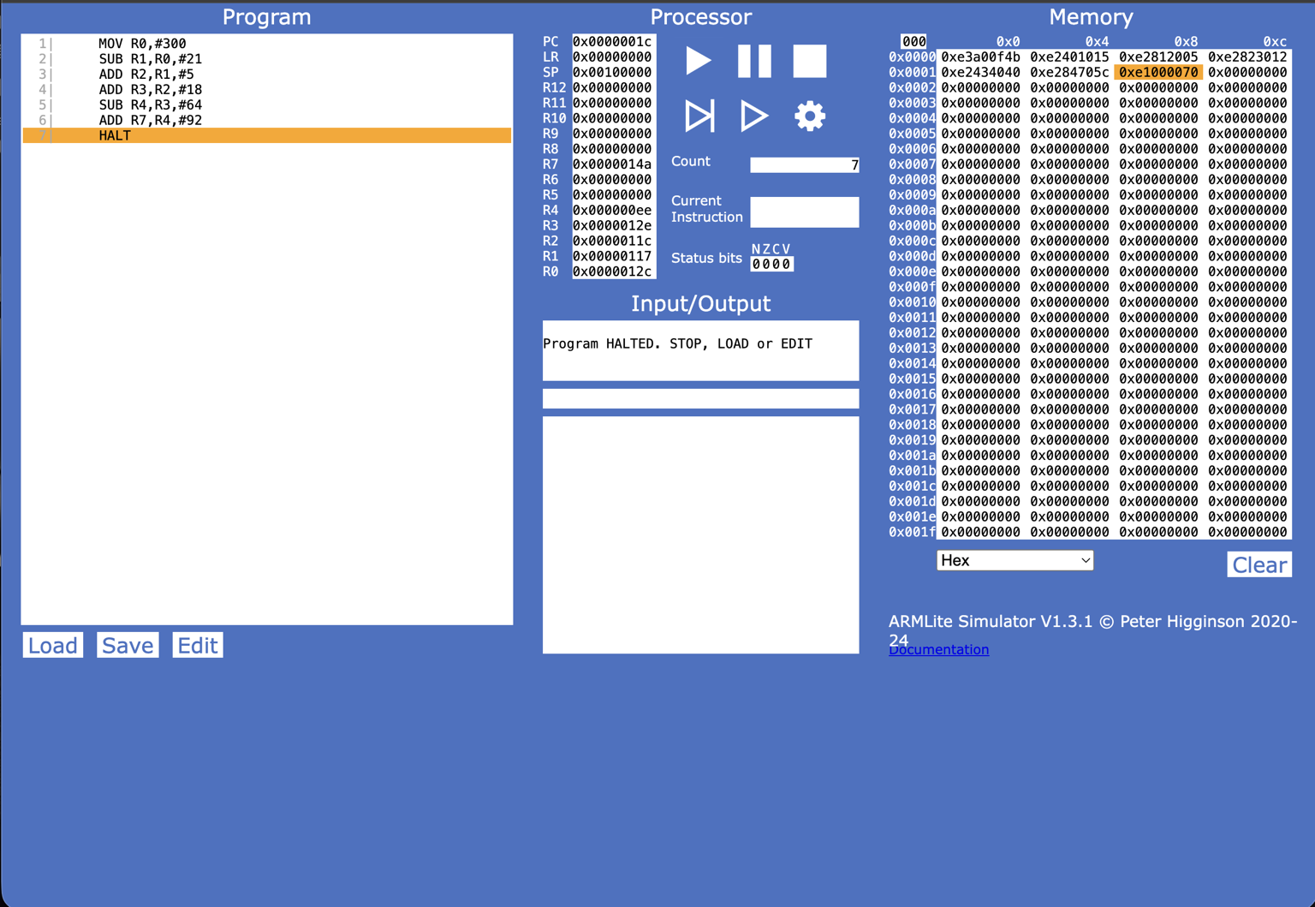
Instruction | Decimal value of the destination register after executing this instruction | Binary value of the destination register after executing this instruction
MOV R0,#20 | 20 | 00010100
AND R1,R0,#15 | 4 | 00000100
ORR R2,R1,#8 | 12 | 00001100
EOR R3,R2,#3 | 15 | 00001111
LSL R4,R3,#2 | 60 | 00111100
LSR R5,R4,#1 | 30 | 00011110

7.5.5
My calculation:
12 + 11 + 7 + 5 + 3 + 2 = 40

Apply LSL #1
40 x 2 = 80
Minus 1:
80 - 1 = 79
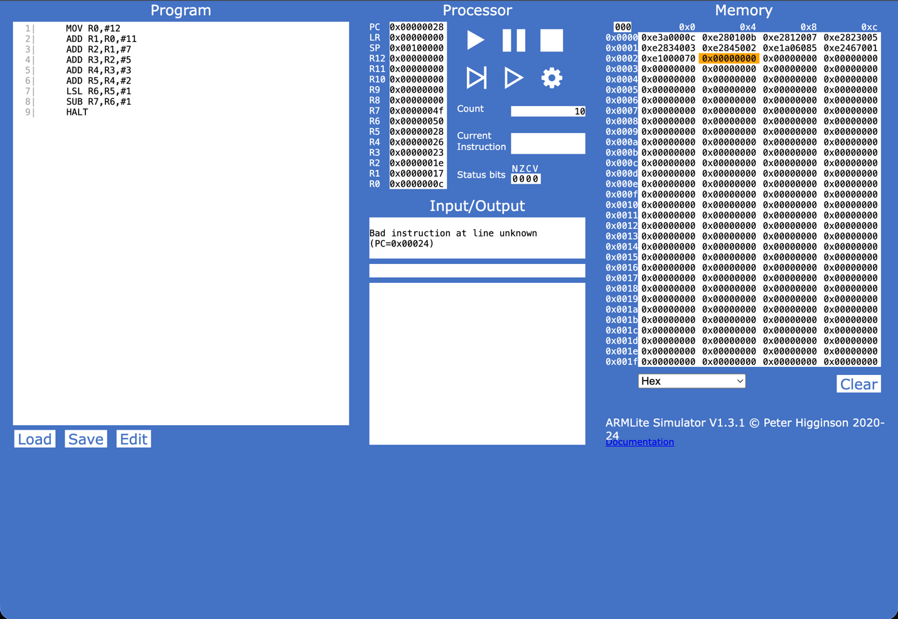
7.5.6
My calculation:
33 - 31 = 2
2^4 = 32
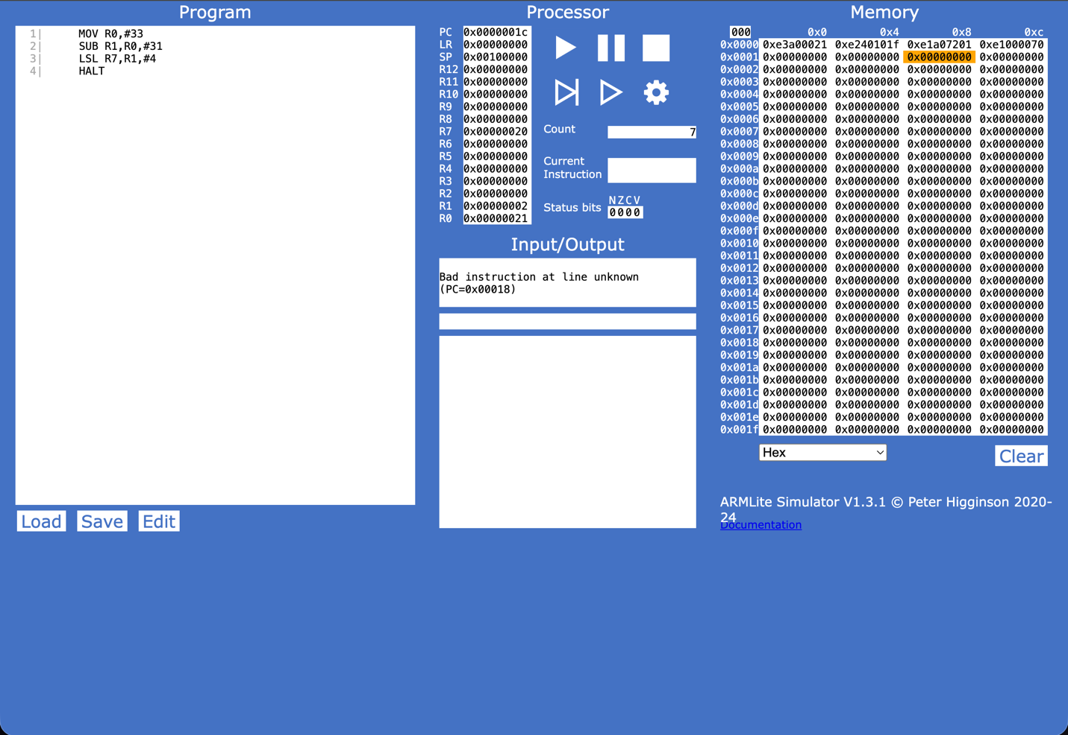
7.6.1
The result in R1 becomes a negative number because the register only stores 32 bits. When the instruction LSL R1, R0, #18 runs, the value 9999 is shifted 18 bits to the left, which makes the number much bigger.
During this shift, some bits move into the most significant bit (the first bit). In a 32-bit signed number, if the first bit is 1, the system treats the number as negative using two’s complement.
So even though we started with 9999, after shifting the bits the binary pattern changes a lot, and the sign bit becomes 1, which is why ARMlite shows a negative decimal value in R1.
7.6.3
Binary values (32-bit):
1 → 00000000 00000000 00000000 00000001
-1 → 11111111 11111111 11111111 11111111
2 → 00000000 00000000 00000000 00000010
-2 → 11111111 11111111 11111111 11111110
Pattern:
Positive numbers start with 0, while negative numbers start with 1. Negative numbers are basically the two’s complement of the positive number.
7.6.4
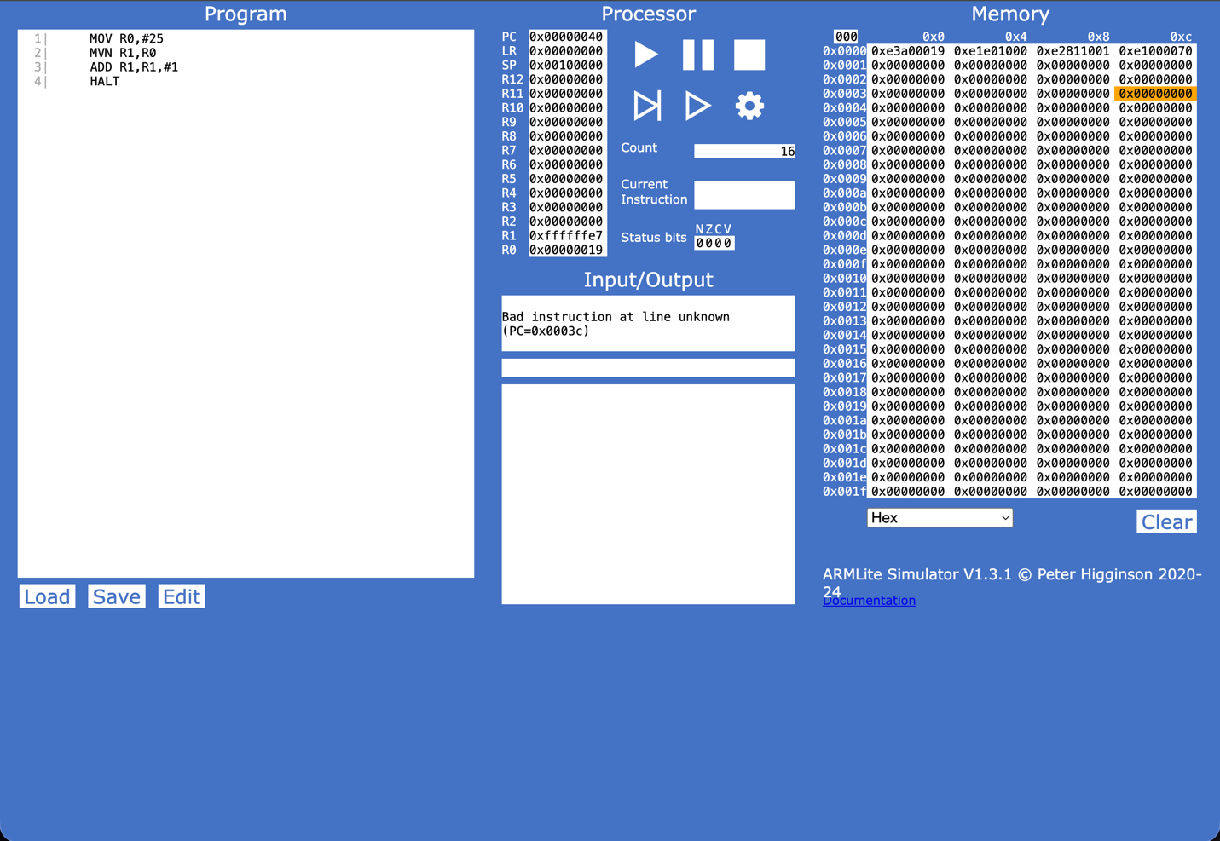
Explanation:
First, the number is moved into R0. Then the instruction MVN flips all the bits of that number. After that, ADD R1, R1, #1 adds 1 to the result. These two steps together create the two’s complement, which converts the positive number into its negative version.
When I try the program again using the negative number as the input, it converts back to the positive number. This shows that the two’s complement method works both ways (positive ↔ negative).
What do you notice?
When I use the negative value as input and run the program again, it converts back to the positive number. This shows that two’s complement works both ways (positive ↔ negative).

